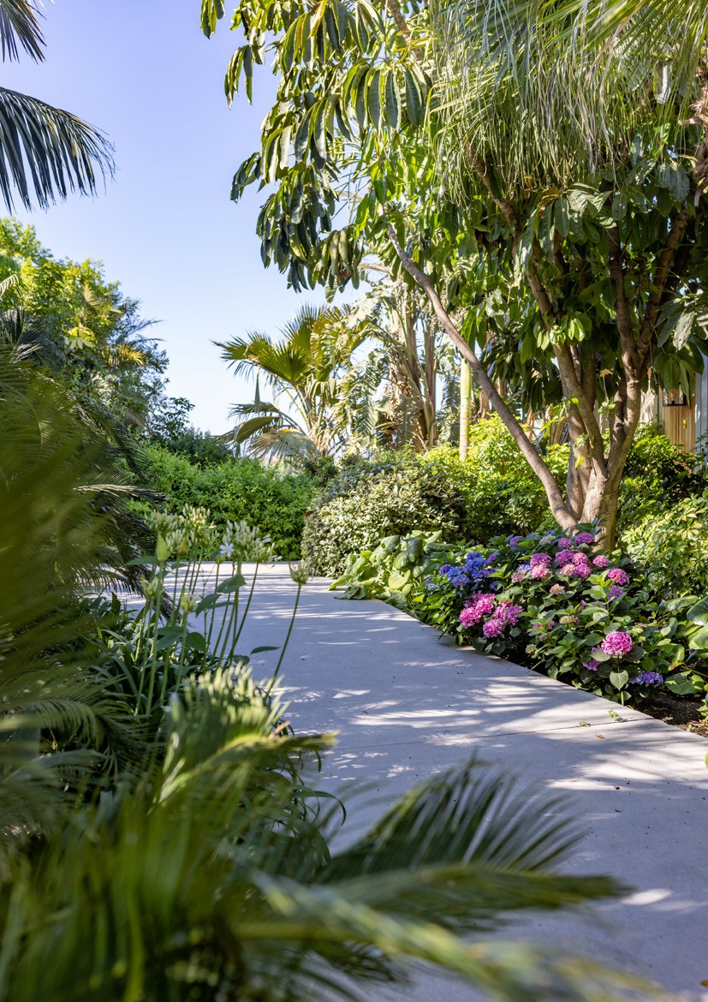

D O N N A C A R M E L A

RE SO R T & LO D G E S

## A C T I V I T Y G U I D E

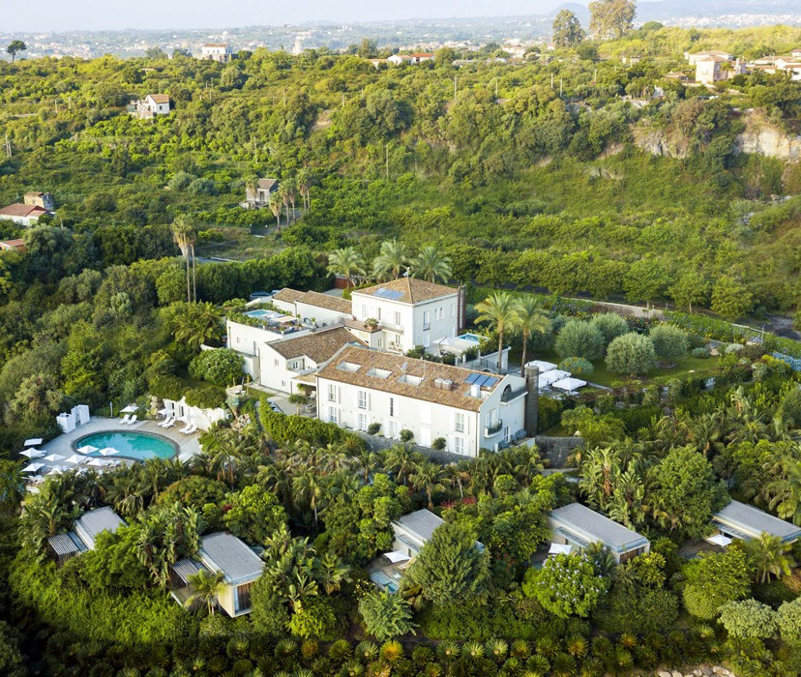

Please contact [**guestrelation@donnacarmela.com**](mailto:guestrelation@donnacarmela.com) **whatsapp: +39 345 81 91 216**

for reservations or information.

Click here and contact Guest Relation.

Dear Guests,

We have created this guide to better plan your stay.

Nothing will be left to the case, our staff will take care of organizing everything in great detail. In this guidebook we propose a variety of activities, inside and outside our resort, that will enrich your experience at Donna Carmela Resort & Lodges and make your stay unforgettable.

Let our Guest Relations suggest the best option for you , they are always at your complete disposal.

#### Dip into a world of Sicilian adventures!

**ACTIVITIES INSIDE THE RESORT**

M A S T E R C L A S S

# SICILIAN CANNOLO

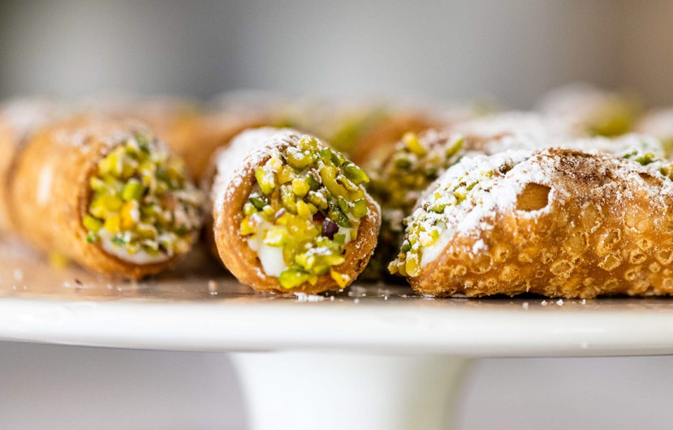

**WITH RICOTTA CHEESE**

**Duration:** 40 minutes.

**Time:** to be decided.

**Location:** outdoor terrace of the restaurant or under the olive trees. In case of bad weather conditions it will be held in the restaurant hall. **Participants:** 2 to 4 people.

**What is included:** cannoli peel dough, cannoli closing, baking, refilling and presentation.

Tasting of the cannoli with a passito wine combination. Complimentary apron and chef's hat.

**Cost € 60.00 per person – children under 7 years old attend free of charge**

# ARANCINO AL RAGÙ

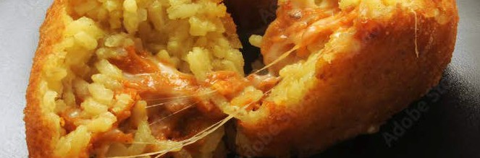

***Vegetarian on request***

**Duration:** 50 minutes.

**Time:** to be decided.

**Location:** outdoor terrace of the restaurant or under the olive trees. In case of bad weather conditions it will be held in the restaurant hall. **Participants:** 2 to 4 people.

**What is included:** preparation of rice and condiment, assembling, cooking and presentation.

Tasting of arancino.

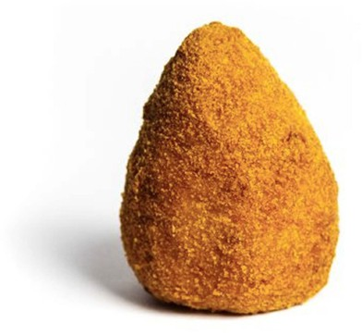Complimentary apron and chef's hat.

**Cost € 65.00 per person - children under than 7 years old participate for free of charge**

# COCKTAIL

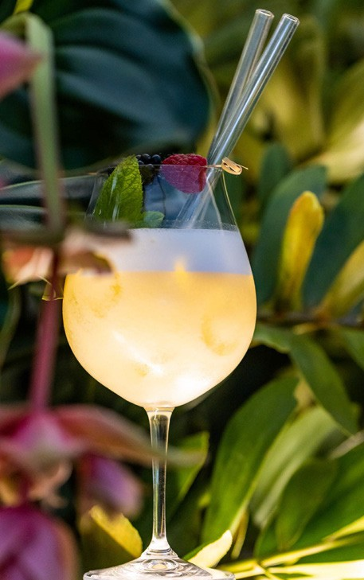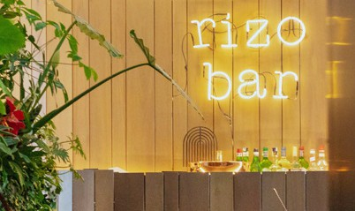

**Duration:** 45 minutes.

**Time:** 5 p.m. to 6 p.m.

**Venue:** Rizo Bar.

**Participants:** 2 to 4 people.

**What it includes:** preparation and tasting of 3 cocktails, using products from our own garden.

Accompanied by 3 typical Sicilian appetizers.

Cost € 60.00 per person

*Our barman is available to customize the selection of cocktails, according to your wishes.*

*Prices on request.*

# WINE TASTING

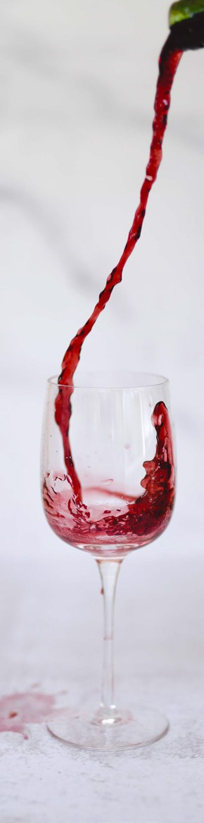

**Duration:** 40 minutes.

**Time:** 5 p.m. to 6 p.m.

**Location:** terrace of the restaurant or under the olive trees. In case of bad weather conditions it will be held in the restaurant hall.

**Participants:** from 2 to 6 people. **What is included:** tasting of 3 wines with combination of Sicilian appetizers.

Cost from € 60.00 per person including 3 Etna classics.

*Our sommelier is at your disposal to customize wine tastings, according to your wishes.*

*Prices upon request.*

# YOGA

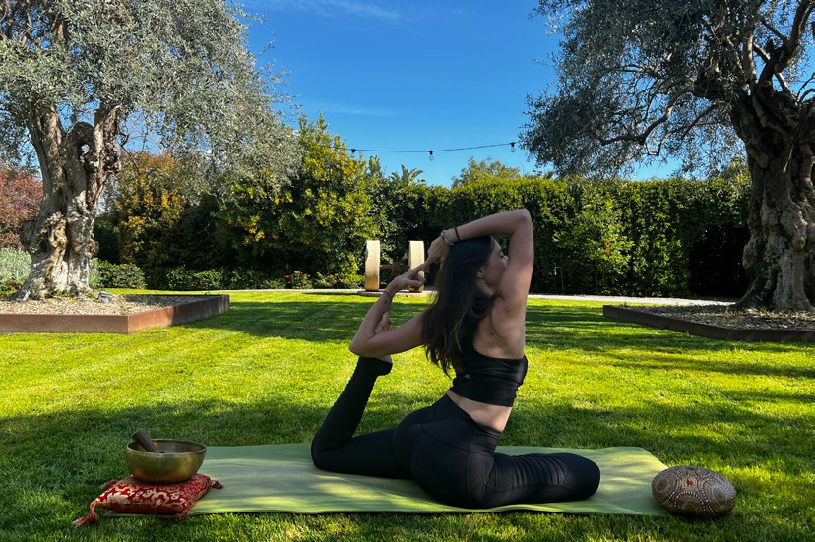

Yoga in the shade of our centuries-old olive trees with a dedicated instructor.

If you would like a lesson, a reservations with our Concierge team is required.

Cost € 90.00 per person.

# E-BIKE

E-bikes under reservation and free of charge for hotel guests.

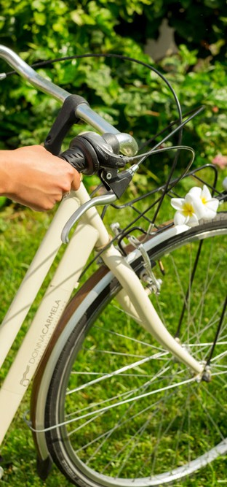

# PADEL COURT

Padel court available upon reservation.

Cost € 100.00 for 90 minutes

(rackets, balls, mineral water included)

## A R O U N D

**DONNA CARMELA RESORT & LODGES**

# PIETRADOLCE

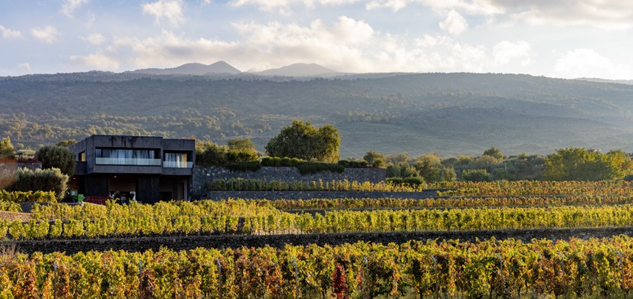

##### the winery, the wine and Etna

Pietradolce is located in Solicchiata, a small village a few kilometers from the town of Castiglione di Sicilia, on the Northern slope of Mount Etna, the most active volcano in Europe (about 3300 mt. asl). Here it is told a story of passion and attachment to the land since 2015.

The estate owns 30 hectares of small plots located within Rampante, Zottorinoto, Santo Spirito e Feudo di Mezzo contradas, in a range between 700 and 950 mt. above sea level. The soils are rather stony, with light sandy loam rich in mineral and volcanic stuff, able to produce unique and elegant wines.

The love for the land, the respect for the ecosystem as well as the deeply respect for the traditions of the Etna area represent the core of the company philosophy. The winery cultivates just indigenous grape varieties, the main characters of its history: Nerello Mascalese and Carricante. The vineyards are grown through the traditional bush vine system “Alberello Etneo”, typical of the vine landscape of Etna.

Through a meticulous handicraft, we produce wines that keep alive the soul and the liveliness of the Volcano.

The hospitality proposals signed by Pietradolce are characterized by the desire to share the fruit of the company’s work with professionals, enthusiasts, and those curious about the world of wine.

Our experiences include a guided tour of the pre-phylloxera vineyards, the wine cellar, and the barrel room, and are completed with a wine tasting in the tasting room.

# PIETRADOLCE

##### Wine experiences

Tasting takes place in our tasting room Monday to Sunday, with prior reservation, and can be conducted in Italian, English or Spanish.

No-drinkers: € 15 per person guided tour.

N.B: Wine offerings are subject to change based on product availability; if some labels are missing, they will be replaced by other products of equivalent quality range.

###### I TERRITORIALI

The experience includes a walk in the

pre-phylloxera “Archineri” vineyard followed by a visit to the winery. Tasting of 2 Pietradolce wines (classic wines) and 1 wine from the

pre-phylloxera line (Cru) accompanied by bread and Pietradolce EVO oil.

**Price:** € 45 per person **Duration:** approx 1h20m **Wines:** 3

**Esclusivity:** € 50 extra per person

###### LE CONTRADE DELL’ ETNA

The journey through our districts begins in the “Archineri” vineyard, continuing with a visit to the winery and a tasting of 2 Pietradolce wines (classic wines) and 3 wines from the

pre-phylloxera line (Cru) accompanied by bread and Pietradolce EVO oil.

**Price:** € 65 per person **Duration:** approx 1h40m **Wines:** 5

**Esclusivity:** € 50 extra per person

# PIETRADOLCE

##### Wine experiences

###### LE ECCELLENCE DEL VULCANO

A unique experience discovering the Grands Crus Barbagalli & Sant’Andrea begins with a walk to “Vigna Barbagalli”, followed by a visit to the winery. The tasting includes 1 Pietradolce wine (classic wine) and 2 pre-phylloxera wines from the district, Barbagalli and Sant’Andrea, paired with fresh bread and Pietradolce EVO oil.

**Price:** € 100 per person **Duration:** approx 2h **Wines:** 5

**Esclusivity:** € 50 extra per person

###### PIETRADOLCE NEL TEMPO

A dive into the past tasting 3 historical vintages of our Crus among which Barbagalli 2013 and 1 wine from the Pietradolce line accompanied by fresh bread and Pietradolce EVO oil. The proposal is completed with a guided tour of the pre-phylloxera vineyards of Contrada Rampante and the winery.

**Price:** € 150 per person (min. 4 pax)

**Duration:** ca 2h

**Wines:** 4

**Esclusivity:** € 50 extra per person

###### SCENT AND FLAVOURS

An exclusively journey that will accompany you to discover the Etna scents and flavours and the typical cuisine through 5 glasses that will see among the protagonists our excellence, the Grand Cru “Sant’Andrea”.

**Price:** € 150 per person (min. 4 pax)

**Lunch:** Included

**Duration:** ca 2h

**Wines:** 4

**Esclusivity:** Included

# PIETRADOLCE

##### Wine experiences

###### SHOW COOKING PIZZA

More than a simply culinary experience, a show where pizza and wine will accompany each other. The show cooking pizza includes the tasting of three pizzas with different flavours, prepared and baked at the moment, accompanied by a special selection of appetizer with a typical Etnean appeal and pairing of 4 wines signed Pietradolce, two of the Classic range and two pre-phylloxera wines

**Price:** € 140 per person

**Duration:** ca 3h

**Wines:** 4

**Min** 12 people

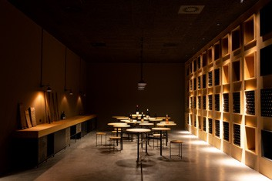**Esclusivity:** Included

###### WINE TASTING IN THE CELLAR

You can book the private tasting inside the historic bottle vault. Available with all wine experiences.

**Extra charge:** € 30 per person

###### 

###### TASTING IN THE HOUSE OF CAMPAIGN

You can book the private tasting at our country house in Contrada Rampante overlooking the pre-phylloxera vineyard in Archineri. A tour of the winery is included. Available with all wine experiences except "I territoriali."

**Extra charge:** € 40 per person

* Supplement of € 13 per person to the agreed experience to taste a selection of products
* Please let us know at the time of booking any food allergies or specific dietary needs.

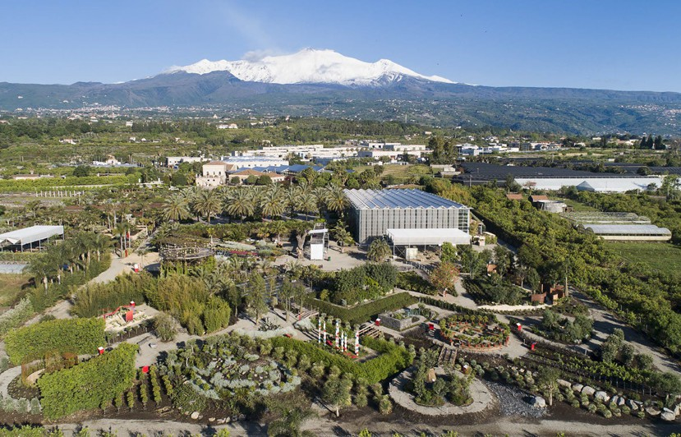

# RADICEPURA

##### the botanical garden

It is possible to visit by reservation the Radicepura Botanical Park, inside which are the installations and gardens of the **V edition** of the **Radicepura Garden Festival**: *“CHAOS (and) ORDER IN THE GARDEN”.*

Tours by reservation

Adults and children 12 to 16 years old

€ 10.00

Children under 12 participate for free

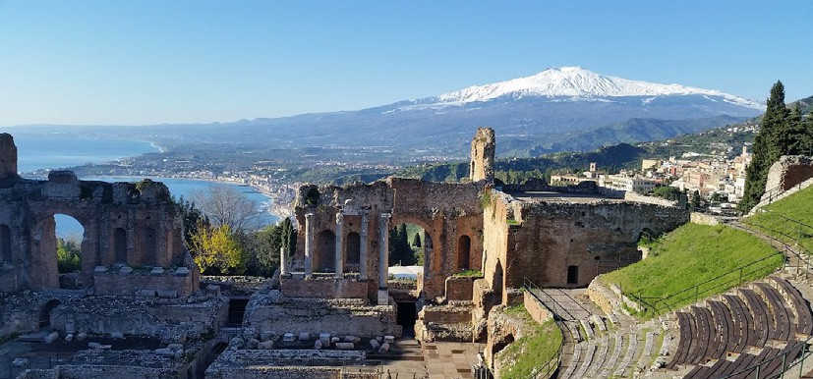

# TAORMINA

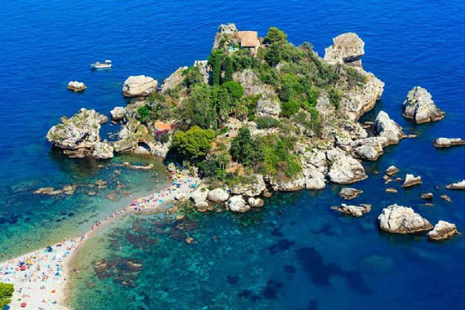

A small town that has always evoked the charm of the Italian dolce vita until the contemporary reminder with the second season of "White Lotus." A corner therefore all to be discovered between the sea breeze and the enchantment of ancient ruins.

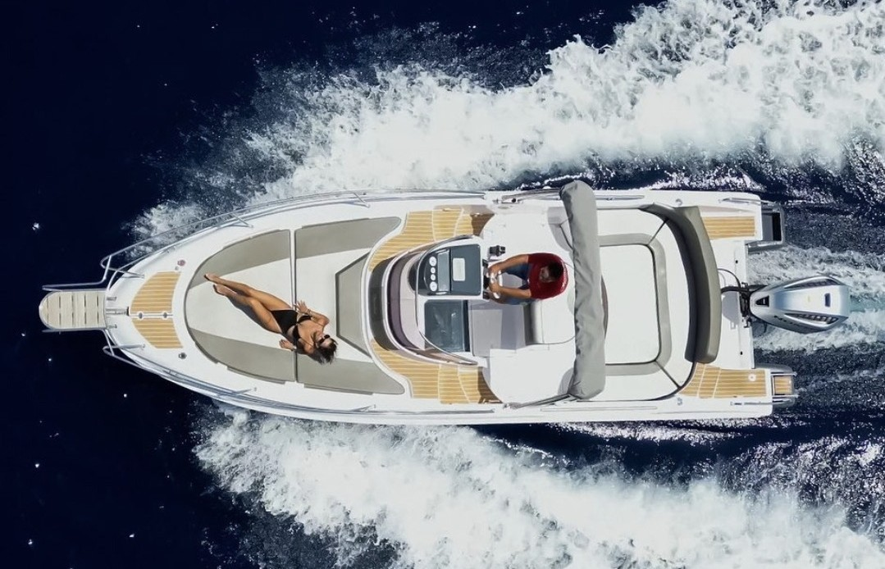

# LUXURY BOAT EXPERIENCE

Navigate between the enchanting bays of Giardini Naxos and Capo Taormina, the famous Isola Bella, Mazzarò Bay, Baia delle Sirene and Scoglio dell'Elefante, on a

9-meter boat equipped with all amenities, bathroom, shower, kitchen, refrigerator and 2 sundecks at the bow and stern.

Tour duration, up to 6 people:

**3 hour and half private tour** € 750,00

**8 hour private tour** € 1300,00

Included in the price: skipper, snacks, prosecco, fresh fruit, water and soft drinks. Departure from Giardini Naxos and private driver transfer upon request.

Service available from May to October.

Cancellation policy: cancellation is free up to 36 hours before departure. After 36 hours a cancellation fee of 50% of the total services booked will be charged.

# TAORMINA BOAT EXCURSIONS

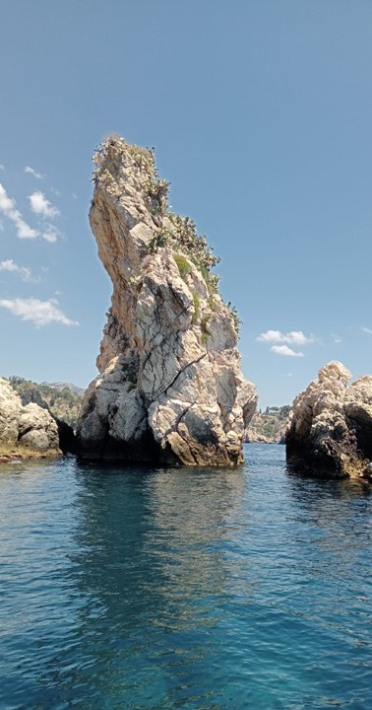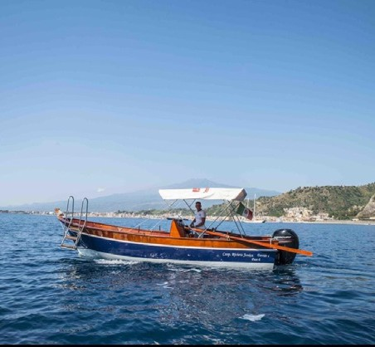

Exclusive boat tours, departing from the Bay of Mazzarò, to discover the Bay of Taormina, Blue Grotto, Siren Bay, St. Andrea Cave and Isola Bella.

2 hour tour:

**Up to 2 people:** € 110,00 per person; **Up to 4 people:** € 95,00 per person; **Up to 6 people:** € 85,00 per person;

4 hour tour:

**Up to 2 people:** € 295.00 per person; **Up to 4 people:** € 165.00 per person; **Up to 6 people:** € 120.00 per person;

Included in the price: Skipper, snacks, prosecco, fresh fruit, water and soft drinks.

**Service available from May to October.** Cancellation policy: cancellation is free of charge up to 36 hours before departure. After 36 hours, a cancellation fee of 50% of the total booked services will be charged.

# CYCLOPS TOUR BY BOAT APHRODITE

###### CLASSIC TOUR

Departing from the port of Pozzillo, we will be coasting the volcanic nature coast below the Timpa Orientata of Acireale, passing through the seaside villages of Stazzo, Santa Tecla, and Santa Maria la Scala.

Things to see:

* Pirate watchtower from the 1500s
* Columnar basalts of Santa Maria la Scala - Grotta delle Palombe
* Sarpa Stone
* Mill Beach

You will have a 20-minute swim stop in the beautiful waters of the Ionian Sea where you will have the opportunity to snorkel. On your return to the boat you will be offered fresh seasonal fruit with Prosecco. Proceeding for the return trip there will be a sail away from the coast so you can admire majestic Etna in all its splendor, with the possibility of some dolphin and sea turtle sightings.

**Duration:** 2 hours and 30 minutes

**Collective: Adults**

€ 66.00 per person (min. 4)

**Children**

€ 46,50 - 5 to 10 years old

**Exclusivity**: € 462,00 - 2 people

€ 528,00 - 4 people

€ 660,00 – 6 people

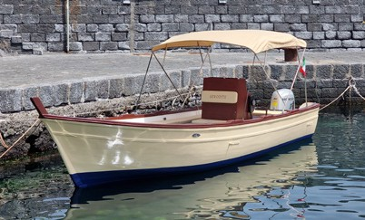 € 792,00 – 8 people**ACI TREZZA TOUR**

Departing from the port of Pozzillo, we will skirt the volcanic nature coastline below the Timpa Orientata of Acireale, reaching the seaside villages of Stazzo, Santa Tecla, Santa Maria la Scala, Capo Mulini and Aci Trezza where you will have the opportunity to go ashore.

Things to see:

* Pirate watchtower from the 1500s
* Columnar basalts of Santa Maria la Scala - Grotta delle Palombe
* Sarpa Stone
* Mill Beach
* Mythological stacks of the legendary Polyphemus

You will make two swim stops of 20 minutes each with the possibility of snorkeling in the beautiful waters of the Ionian Sea. Upon return to the boat you will be offered fresh seasonal fruit with Prosecco. During the return trip, navigation away from the coast will be made so you can admire majestic Etna in all its splendor, with the possibility to sea some dolphin and sea turtle.

**Duration:** 4 hours

**Collective: Adults**

€ 112,50 per person (min. 4)

**Children**

€ 66,000 - 5 to 10 years old

**Exclusivity**: € 594,00 - 2 people

€ 660,00 - 4 people

€ 792,00 – 6 people

€ 924,00 – 8 people

***language spoken on board Italian,***

***extra cost for English speaking***

***per boat € 80.00***

# ETNA

##### many ways to discover the volcano

Big and mighty, alive and at times irreverent. It is Our great volcano that dominates the territorial scene and in every season gives memorable experiences.

### Etna Morning

A half‑day excursion to explore flank craters and cooled lava flows between 1,800 m and 2,100 m, uncovering the region’s geology, botany, and culture away from the typical tourist trails

### Etna Sunset

A sunset excursion up to 2,900 m—where the Observatory is located—to experience the majesty of the active volcano.

### Etna Morning Trekking

A trek across the flank craters that destroyed Piano Provenzana in 2002, perfect for hiking enthusiasts.

### Cableway + Hiking

A guided excursion among the flank craters and the “black desert” above 2,500 m on Etna’s southern slope.

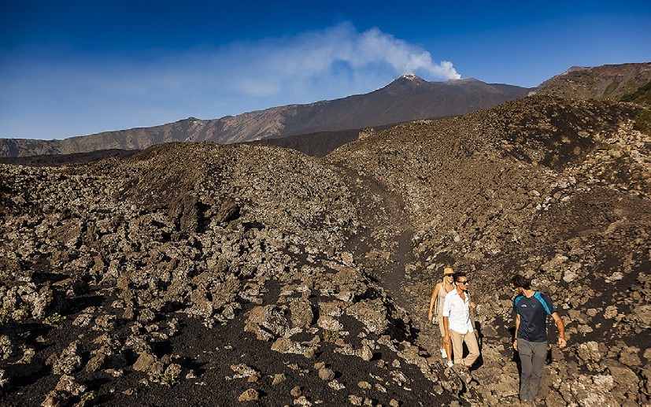

### Etna Jeep Tour

### A visit to the 2002 lava flow, the Corruccio Cave, and the Sartorius Mountains’ craters, followed by a wine tasting at a local winery—and an exploration of the region’s endemic fauna and flora.

# INDIVIDUAL TOURSAND/ OR CUSTOMIZABLE

Private and customized tours are organized upon request.

# *All excursions include expert guides and recommended basic equipment, with the option to customize your tour upon request. Recommended gear includes: long trousers, a backpack, a rain/wind jacket (available for rent), a fleece and gloves in colder seasons, trekking poles (optional, provided), a hat, and sunscreen.*

**L’Etna in Ebike   
  
  
 Esperienza mattutina   
   
 Etna Crateri 3000 metri  
 Etna Crateri Sommitali 2700 metri   
 Etna Alba  
 Etna Wine Tasting in E-Bike  
  
  
 Esperienze pomeridiane   
   
 Etna Tramonto di 4 ore circa**

# Questa suggestiva ed unica esperienza è adatta anche ai più piccoli! Con la possibilità di meeting point o di pick-up dal Resort, tutto con l’assistenza del nostro front desk

# Immagine che contiene trasporto, aeromobile, elicottero, aria aperta Il contenuto generato dall'IA potrebbe non essere corretto.HELICOPTER TOURS

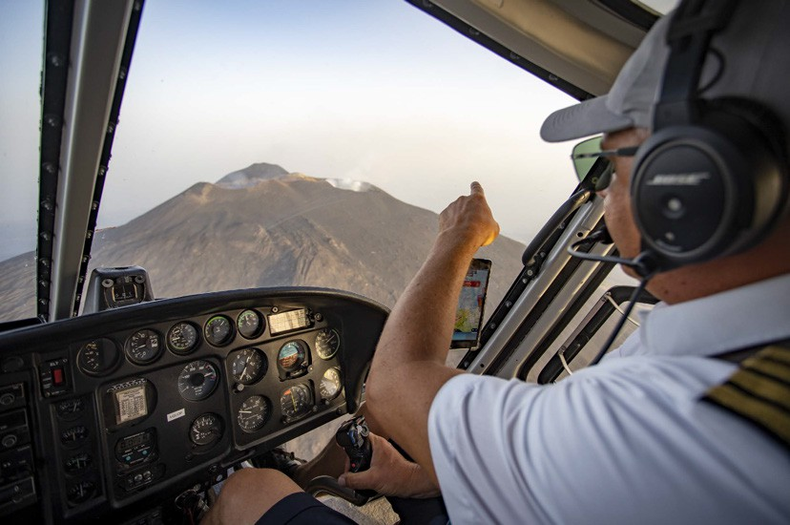

See the volcano Etna and the enchanting Taormina from a unique

view point. Helicopter tours are a concentrate of emotions,

breathtaking views that will make your trip unforgettable.

**Private tour of Etna volcano** - tour duration 30 minutes € 1500,00

**Private tour of Taormina and Etna volcano** - tour duration 35 minutes € 1700,00 NETTI

**Helicopter**: Airbus AS350 (up to 5 passengers + Pilot) - Single-engine

**Included:**

Mineral Water, Welcome Drink/Coffee

**NOT Included:**

Any transfer from/to the resort and meeting point

Service available from May to October.

Cancellation Policy: cancellation is free up to 36 hours before departure.

After 36 hours, a cancellation fee of 50% of the total booked services will be charged.

Maximum weight 105 kg per passenger.The activity is not suitable for people with heart disease and pregnant women. Children are welcome. The experience by helicopter over Etna volcano requires good weather. If it is cancelled due to bad weather, a different time/date or itinerary will be proposed

# HORSE RIDING

###### SHORT WALK

Appropriate for beginners, includes a ride within the "Old Feud." Through citrus groves and flat terrain.

**Duration:** 1 hour **Difficulty:** easy **Fee:** € 35.00

###### WALK TO THE SEA

Suitable for beginners and experts. Route of about 10 km. Starting from the Headquarters of Trappitello you follow the Mouth of the Santa Venera River until you reach the beach of Recanati (Giardini Naxos) and return.

N.B Excluding the summer period (due to bathers on the beach).

**Duration:** about 2 hours and thirty minutes

**Difficulty:** medium-easy

**Price:** €60.00

###### SHORT WALK PLUS

Appropriate for beginners, includes a short ride to the Alcantara River and back again.

**Duration:** 1 hour and thirty minutes

**Difficulty:** easy

**Price:** € 45.00

###### ALCANTARA WALK

Appropriate for beginners and experts. Approximately 8 km route. Start from the Trappitello headquarters and follow the path of the Alcantara River and cross it several times. After a brief visit to an old lava flow and several breaks, you return.

**Duration:** about 2 hours and thirty minutes

**Difficulty:** medium-easy

**Price:** € 60.00

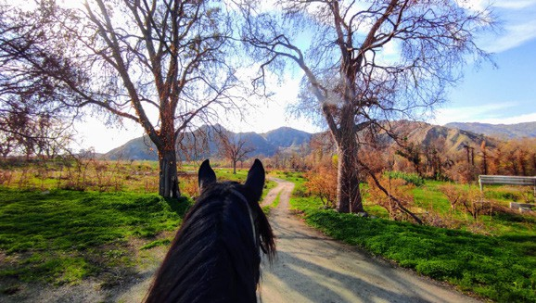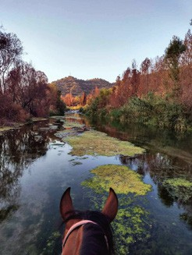

#### RESORT ACTIVITIES:

Masterclass reservation 48 hours in advance is required. Free cancellation within 12 hours prior to the masterclass.

#### OTHER ACTIVITIES:

See specific conditions

Please feel free to contact our Concierge Team for any needs, including wellness treatments, babysitting, hairdresser and more.

[**guestrelation@donnacarmela.com**](mailto:guestrelation@donnacarmela.com) **whatsapp +39 3458191216**

**Click here and contact Guest Relation.**

##### All activities subject to availability.



[www.donnacarmela.com](http://www.donnacarmela.com/)